Guidelines for the Standardized Citation of AKERN Bioimpedance Technologies in Scientific and Clinical Publications
1. Purpose and Scope
This document provides standardized guidance for the correct citation and reporting of AKERN bioimpedance technologies in peer-reviewed publications, clinical reports, and research protocols.
Accurate methodological reporting is essential to:
- Ensure scientific reproducibility
- Prevent technological misattribution
- Preserve methodological transparency
- Maintain the integrity of bioimpedance research
These guidelines are intended for researchers, clinicians, reviewers, and journal editors who report data obtained using AKERN bioimpedance devices and related software platforms.
2. General Principles for Citation
When reporting AKERN bioimpedance measurements, the following elements must be explicitly stated in the Materials and Methods section:
2.1 Device Identification
- Full commercial name of the device
- Manufacturer (AKERN srl)
- City and Country (Florence or Pisa, Italy, according to production year)
- Production period (when relevant for technical specifications)
Example:Bioimpedance analysis was performed using a phase-sensitive single-frequency analyzer (BIA 101 BIVA PRO, AKERN srl, Pisa, Italy).
2.2 Electrical Characteristics
The following technical parameters must be reported:
Parameter | Description
Current (µA) | Injected alternating sinusoidal current
Frequency | Operating frequency (50 kHz ± tolerance)
Accuracy | R and Xc accuracy (%)
Resolution | Ω resolution
CV% | Coefficient of variation

2.3 Measurement Configuration
Specify:
- Whole-body or regional configuration
- Tetrapolar electrode placement
- Body position (supine, limb angle)
- Skin preparation procedure
- Pre-test fasting conditions

Accurate methodological reporting ensures reproducibility, appropriate interpretation of impedance-derived parameters, and correct technological attribution.

3.0 Table of devices
Device model | Life cycle | How to cite the technology | Technology
BIA 101  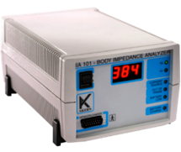 | 1998  - 2009 | Whole body bioimpedance (BIA 101 AKERN, Florence, Italy) was performed using an alternating sinusoidal electric current of 800 microampere at an operating frequency of 50 kHz. The calibration of the device was checked each day measurements were performed, always at the first measurement of the day, using the standard control circuit supplied by the manufacturer with a known impedance [resistance (R) = 380 Ohm; reactance (Xc) = 47 Ohm]. The accuracy of the device was 1% for R and 2% for Xc. For the BIA measurement, each participant was supine with limbs slightly spread apart from the body. Disposable tab electrodes (BIATRODES Akern Srl; Florence, Italy) were placed on the right side at metacarpal and metatarsal sites of the right wrist and ankle [a]. | 800 µA current at 50 kHz (±2%), resolution Rz: ±1%, Xc: ±2%,  CV% <3,5%
BIA 101 New Edition  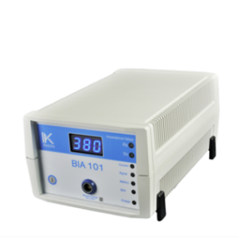 | 2010  - 2019 | Whole body bioimpedance (BIA 101 new edition AKERN, Florence, Italy) was performed using an alternating sinusoidal electric current of 400 microampere at an operating frequency of 50 kHz. The device was calibrated every morning using the standard control circuit supplied by the manufacturer with a known impedance [resistance (R) = 380 Ohm; reactance (Xc) = 47 Ohm]. The accuracy of the device was 1% for R and 2% for Xc. For the BIA measurement, each participant was supine with limbs slightly spread apart from the body. Disposable tab electrodes (BIATRODES Akern Srl; Florence, Italy) were placed on the right side at metacarpal and metatarsal sites of the right wrist and ankle [a]. | 400 µA current at 50 kHz (±1%), resolution Rz: ±1%, Xc: ±2%,  CV% <2,8%
BIA 101 BIVA  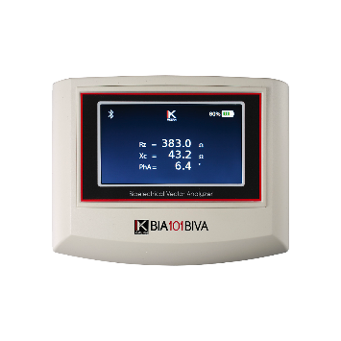 | 2019 - 2020 | Whole body bioimpedance (BIA 101 BIVA AKERN, Pisa, Italy) was performed by a phase sensitive device working with alternating sinusoidal electric current of 250 microampere at an operating frequency of 50 kHz (±1%). The device was calibrated every morning using the standard control circuit supplied by the manufacturer with a known impedance [resistance (R) = 380 Ohm; reactance (Xc) = 42 Ohm]. The accuracy of the device was 0.1% for R and 0.1% for Xc. For the BIA measurement, each participant was supine with limbs slightly spread apart from the body. Very low intrinsic impedance (<30 Ohm) disposable electrodes (BIATRODES Akern Srl; Florence, Italy) were placed on the right side at metacarpal and metatarsal sites of the right wrist and ankle [a]. | 250 µA current at 50 kHz (±1%), resolution Rz: ±1%, Xc: ±1%,  CV% <1%
BIA 101 BIVA PRO  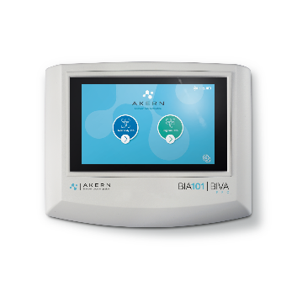 | 01/2021 – 05/2025 | Whole body configuration:  Bioimpedance analysis was performed by a phase sensitive device (BIA 101 BIVA PRO AKERN srl, Pisa, Italy) working with alternating sinusoidal electric current of 245 microampere at an operating frequency of 50 kHz (±1%). The device was calibrated every morning using the standard control circuit supplied by the manufacturer with a known impedance [resistance (R) = 380 Ohm; reactance (Xc) = 45 Ohm]. The accuracy of the device was 0.1% for R and 0.1% for Xc. For the BIA measurement, each participant was supine with limbs slightly spread apart from the body. Very low intrinsic impedance (<30 Ohm) disposable electrodes (BIATRODES Akern Srl; Florence, Italy) were placed on the right side at metacarpal and metatarsal sites of the right wrist and ankle [a].  Regional configuration:  Bioimpedance analysis was performed by a phase sensitive device (BIA 101 BIVA PRO AKERN srl, Pisa, Italy) working with alternating sinusoidal electric current of 245 microampere at an operating frequency of 50 kHz (±1%). The device was calibrated every morning using the standard control circuit supplied by the manufacturer with a known impedance [resistance (R) = 345 Ohm; reactance (Xc) = 32 Ohm for left sensing channel and resistance (R) = 380 Ohm; reactance (Xc) = 45 Ohm for the right sensing channel].  The resolution of the device was 0.1 Ω for Rz and 0.1 Ω for Xc in the full range of measurements.  For the regional bioimpedance measurement, each participant was supine with limbs slightly spread apart from the body. Very low intrinsic impedance (<30 Ohm) disposable electrodes (BIATRODES Akern Srl; Pisa, Italy) were placed on both side of the body at metacarpal and metatarsal sites of the right and left wrists and ankles [c]. | 245 µA current at 50 kHz (±1%),  Accuracy:  Rz: ±0.1,%  Xc: ±0.1 %  CV% <1%
BIA 101 BIVA PRO  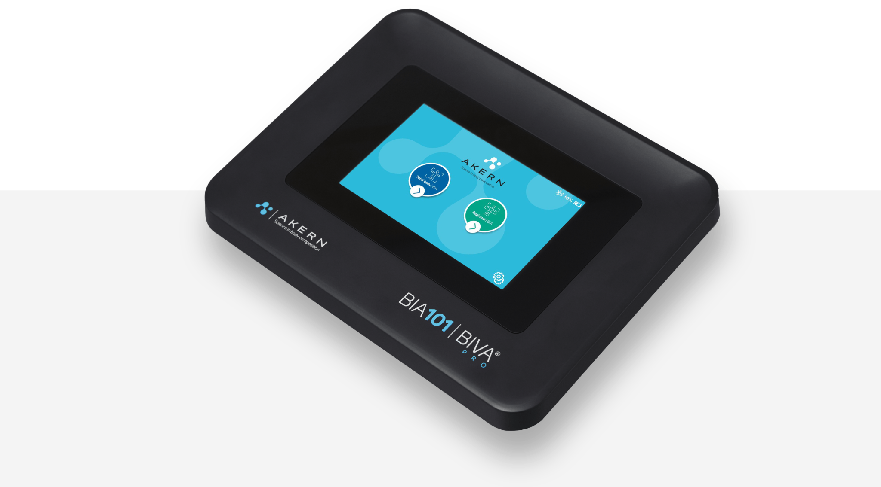 | 05/2025 - Today | Whole body configuration:  Bioimpedance analysis was performed by a phase sensitive device (BIA 101 BIVA PRO AKERN srl, Pisa, Italy) working with alternating sinusoidal electric current of 245 microampere at an operating frequency of 50 kHz (±1%). The device was calibrated every morning using the standard control circuit supplied by the manufacturer with a known impedance [resistance (R) = 380 Ohm; reactance (Xc) = 45 Ohm]. The resolution of the device was 0.1 Ω for Rz and 0.1 Ω for Xc in the full range of measurements. For the BIA measurement, each participant was supine with limbs slightly spread apart from the body. Very low intrinsic impedance (<30 Ohm) disposable electrodes (BIATRODES Akern Srl; Pisa, Italy) were placed on the right side at metacarpal and metatarsal sites of the right wrist and ankle [c].  Regional configuration:  Bioimpedance analysis was performed by a phase sensitive device (BIA 101 BIVA PRO AKERN srl, Pisa, Italy) working with alternating sinusoidal electric current of 245 microampere at an operating frequency of 50 kHz (±1%). The device was calibrated every morning using the standard control circuit supplied by the manufacturer with a known impedance [resistance (R) = 345 Ohm; reactance (Xc) = 32 Ohm for left sensing channel and resistance (R) = 380 Ohm; reactance (Xc) = 45 Ohm for the right sensing channel].  The resolution of the device was 0.1 Ω for Rz and 0.1 Ω for Xc in the full range of measurements.  For the regional bioimpedance measurement, each participant was supine with limbs slightly spread apart from the body. Very low intrinsic impedance (<30 Ohm) disposable electrodes (BIATRODES Akern Srl; Pisa, Italy) were placed on both side of the body at metacarpal and metatarsal sites of the right and left wrists and ankles [c]. | 245 µA current at 50 kHz (±1%),  Accuracy:  Rz: ±0.1,%  Xc: ±0.1 %  CV% <1%

NUTRILAB  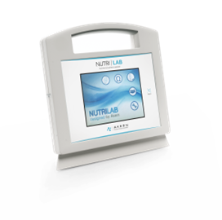 | 2014- 2025 | Bioelectrical impedance was measured with a phase-sensitive touch screen impedance device (Nutrilab, Akern, Florence, Italy), working with alternating sinusoidal electric current of 245 microampere at an operating frequency of 50 kHz (±1%). The device was calibrated every morning using the standard control circuit supplied by the manufacturer with a known impedance resistance (R) = 380 Ohm; reactance (Xc) = 45 Ohm.  Impedance data are shown directly in a LCD touchscreen and stored into an internal memory. The inter observer CV%, evaluated in this healthy cohort is below 1%. | Serial number 2014- 2019:  425 µA current at  50 kHz (±0.1%), resolution Rz: ±0.1%, Xc: ±0.1%,  CV% <2%  Serial number > 2019 245 µA current at  50 kHz (±1%),  Accuracy :  Rz: ±0.1,Ω  Xc: ±0.1 Ω  CV% <1%
NUTRILAB PRO  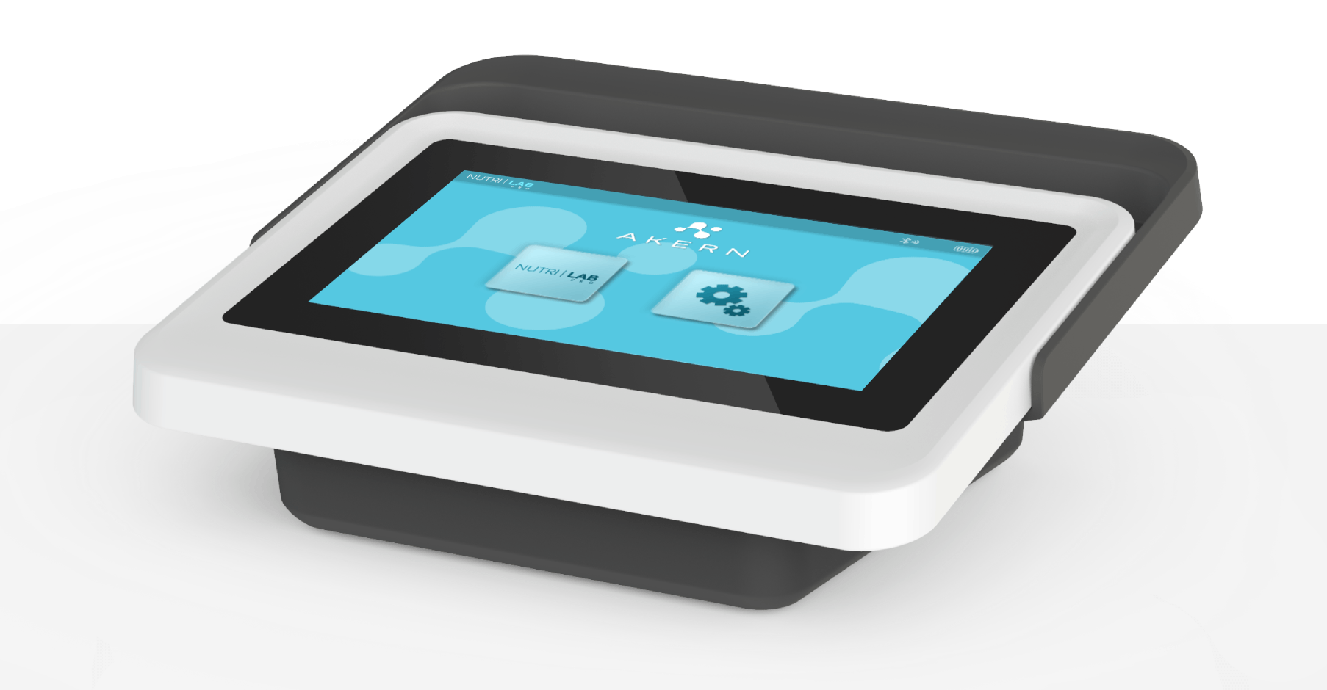 | 05-2025- Today | Bioelectrical impedance was measured with a phase-sensitive touch screen impedance device (Nutrilab PRO, Akern, Florence, Italy), working with alternating sinusoidal electric current of 245 microampere at an operating frequency of 50 kHz (±1%). The device was calibrated every morning using the standard control circuit supplied by the manufacturer with a known impedance resistance (R) = 380 Ohm; reactance (Xc) = 45 Ohm.  Impedance data are shown directly in a LCD touchscreen and stored into an internal memory. The inter observer CV%, evaluated in this healthy cohort is below 1,2%. | Serial number >05- 2025  245 µA current at  50 kHz (±1%),  Accuracy :  Rz: ±0.1,Ω  Xc: ±0.1 Ω  CV% <1%
BIA 101 ASE  Anniversary  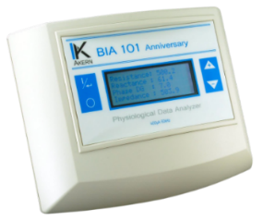 | 2010-2020 | Whole-body impedance was assessed using a single-frequency phase-sensitive analyzer (BIA 101 Anniversary, Akern, Florence, Italy). The device applies an alternating sinusoidal electric current of 400 µA at a fixed frequency of 50 kHz (±0.1%). Impedance was measured via Ag/AgCl surface electrodes placed on the hands and feet at a standardized inter-electrode distance of 5 cm.  Resistance (R, Ω) represents the opposition to current flow through intra- and extracellular ionic solutions, whereas reactance (Xc, Ω) reflects the capacitive properties of cell membranes, intracellular organelles, and tissue interfaces. | 425 µA current at  50 kHz (±0.1%), Resolution Rz: ±0.1%, Xc: ±0.1%, CV% <2%

CARDIOEFG -RENALEFG  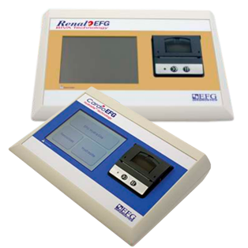 | 2009 -2018 | Bioimpedance vector analysis (BIVA) was performed using tetrapolar impedance plethysmography (CardioEFG, Akern, Florence, Italy), delivering an alternating sinusoidal current of 400 µA at 50 kHz. Resistance (R, Ω) reflects the opposition to current flow through intra- and extracellular ionic solutions, whereas reactance (Xc, Ω) represents the capacitive properties of cell membranes and tissue interfaces.  Data were displayed on an integrated LCD touchscreen and stored in the device’s internal memory. Measurement reproducibility was evaluated in 1.8% of patients; mean coefficients of variation were 0.5% (intra-patient) and 1.6% (inter-operator). Disposable low-impedance proprietary electrodes (BIVATRODES, Akern Srl, Florence, Italy) were positioned on the right side at metacarpal and metatarsal sites of the wrist and ankle, respectively [a]. | 400 µA current at  50 kHz (±1%), Resolution Rz: ±0.1%, Xc: ±0.1%, CV% <2%
EFG v.3   | 2005-2010 | Whole-body impedance data were obtained using a tetrapolar impedance plethysmography (EFG V.3 Akern, Florence, Italy). The bioelectrical parameters of resistance and reactance were measured using an electric alternating current flux of 400 amperes and an operating frequency of 50 kHz. Whole-body impedance measurements were taken according to the standard protocol of Lukaski et al [a]. | 400 µA current at  50 kHz (±2%), Resolution Rz: ±1%, Xc: ±1%, CV% <2%
BIATRODES  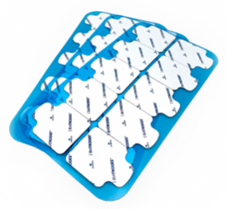 | 1998- Today | Two pairs of adhesive Ag/AgCl low impedance electrodes (BIATRODES Akern Srl; Pisa, Italy) were placed proximal to the phalangeal–metacarpal joint on the dorsal surface of the right hand and distal to the transverse arch on the superior surface of the right foot. Sensor electrodes were placed at the midpoint between the distal prominence of the radius and ulna of the right wrist, and between the medial and lateral malleoli of the right ankle at a fixed distance of 5 cm each other.
BIVATRODES   | 2012- Today | Two sets adhesive Ag/AgCl low impedance electrodes (BIVATRODES Akern Srl; Pisa, Italy), designed for accurate and sensitive bioimpedance measurements were placed proximal to the phalangeal–metacarpal joint on the dorsal surface of the right hand and distal to the transverse arch on the superior surface of the right foot. Sensor electrodes were placed at the midpoint between the distal prominence of the radius and ulna of the right wrist, and between the medial and lateral malleoli of the right ankle.

Bodygram™ 1.31 | 1998 | EOL (End of Life) | na
Bodygram™ PRO | 2008 | EOL (End of Life)
Bodygram ™ Plus | 2014 | End of service
Bodygram™ Dashboard V.3.0 | 2020-today | Cloud based software for body composition components estimation and graphical representation of the parameters.
Bodygram™ HBO | 2020-today | Stand alone, multi users, GDPR compliant software for body composition components estimation and graphical representation of the parameters.
Bodygram™ HBO Advanced | 2026-today | Stand alone, multi users, GDPR compliant software for clinical body composition analysis including estimation of components and bioelectrical norms updated to the state of AKERN ‘s research and registered into EUDAMED .

MATERIAL and METHOD: sample paragraph
Bioelectrical impedance was assessed using a phase-sensitive, single-frequency analyzer (MODEL [XXXX], Akern Srl, Pisa, Italy), delivering an alternating sinusoidal current of ___ µA at 50 kHz. Measurements were obtained in a tetrapolar configuration according to the standardized protocol described by Prado et al. [a]. Participants were evaluated in the supine position, with the upper limbs abducted at approximately 30° and the lower limbs separated at approximately 45° from the midline. After cleansing the skin with isopropyl alcohol to reduce surface impedance, Ag/AgCl low-intrinsic-impedance electrodes (BIATRODES, Akern Srl, Italy) were placed on the dorsal surface of the right hand and right foot, maintaining a fixed 5 cm inter-electrode distance [b]. To minimize acute variations in hydration status, participants were instructed to abstain from food and fluids for at least 4 hours before measurement [c,d].

Bibliographic reference:
[a]Prado, Carla M., et al. "Methodological Standards for Body Composition Assessment-an Expert-Endorsed Guide for Research and Clinical Applications: Bioimpedance, Dual-energy X-ray Absorptiometry, Computerized Tomography, and Ultrasound Methods." The American Journal of Clinical Nutrition (2026): 101283.
[b] Dunbar, Christopher C., et al. "Effects of small errors in electrode placement on body composition assessment by bioelectrical impedance." Research quarterly for exercise and sport 65.3 (1994): 291-294.
[c] Kushner, Robert F., Rani Gudivaka, and Dale A. Schoeller. "Clinical characteristics influencing bioelectrical impedance analysis measurements." The American journal of clinical nutrition 64.3 (1996): 423S-427S.
[d] Slinde, Frode, and Lena Rossander-Hulthén. "Bioelectrical impedance: effect of 3 identical meals on diurnal impedance variation and calculation of body composition." The American journal of clinical nutrition 74.4 (2001): 474-478.

